1. Create a web page which contains the fields like Fname, Lname, age, address, City. Have the radio buttons and check box as per your respective design.Use JSPs, CSS and JSTL tags. Also write simple Javascript method to validate the above fields.







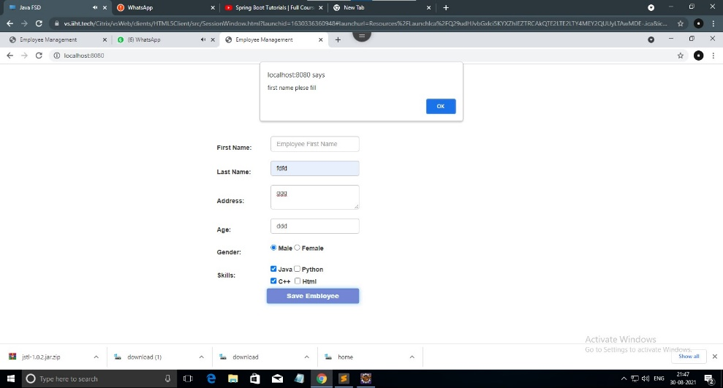

1. Write a standalone class to show how to connect to the Database(mysql) from Java application.



1. Create simple web pages using Angular Js and React Components.



